What is propaganda?
(Not just images/posters but radio, TV, films and newspapers. The Germans were brilliant at propaganda too.)
Dylan Thomas was graded C3 in his wartime army medical due to poor physical health and so was placed amongst the last group of men to be called up for active service. Around 1941 he began working for Strand Films and it is believed that he was involved in scriptwriting propaganda films.

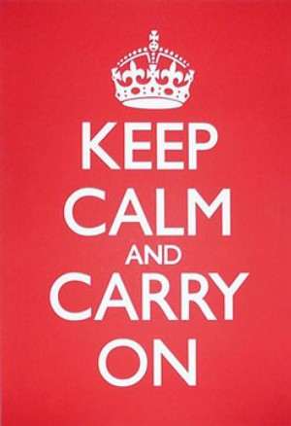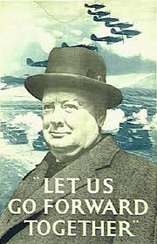

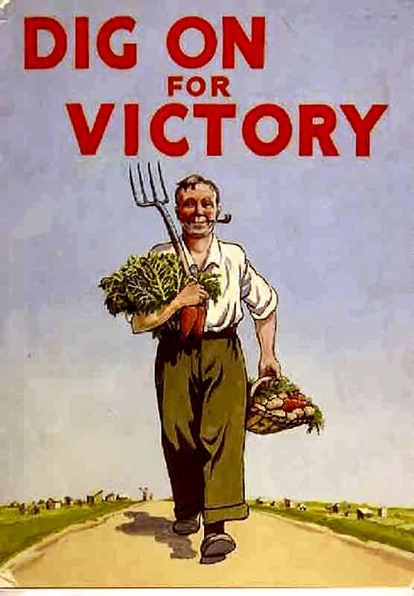

What message is the poster trying to get across?
Who is the poster aimed at?
How did the poster make people feel?
Why was it so important that people took notice of the posters?
How was using a poster an effective way to get messages across?
What is the poster influencing the public into thinking?
What are the main colours used in the poster? Why do you think these colours were used?
Are the messages in the poster mainly: Visual (pictures), Verbal (words), or a mixture of both?

Teaching ideas

More detailed information can be found at this BBC site:
How did Dylan Thomas help Wartime Propaganda? http://www.bbc.co.uk/guides/zpt22hv

- Use a slogan from a WW2 Propaganda poster and design your own poster.
-Keep Mum ... Keep Dad Safe
-Coughs and Sneezes spread diseases
-Put that Light OUT!!
-Make do and mend
-Hitler will send no warning
-Your courage will bring us VICTORY

- Upper Key Stage 2 learners could think of their own. Discuss the language that would be used. Play on words, alliteration, etc.

- Re-enact ‘Make do and Mend’ using dolls and recycled materials. Learn to sew or knit with the help of a parent/grandparent/member of the community.

- Create a script for a propaganda film that might have been shown in the cinema during WW2.

